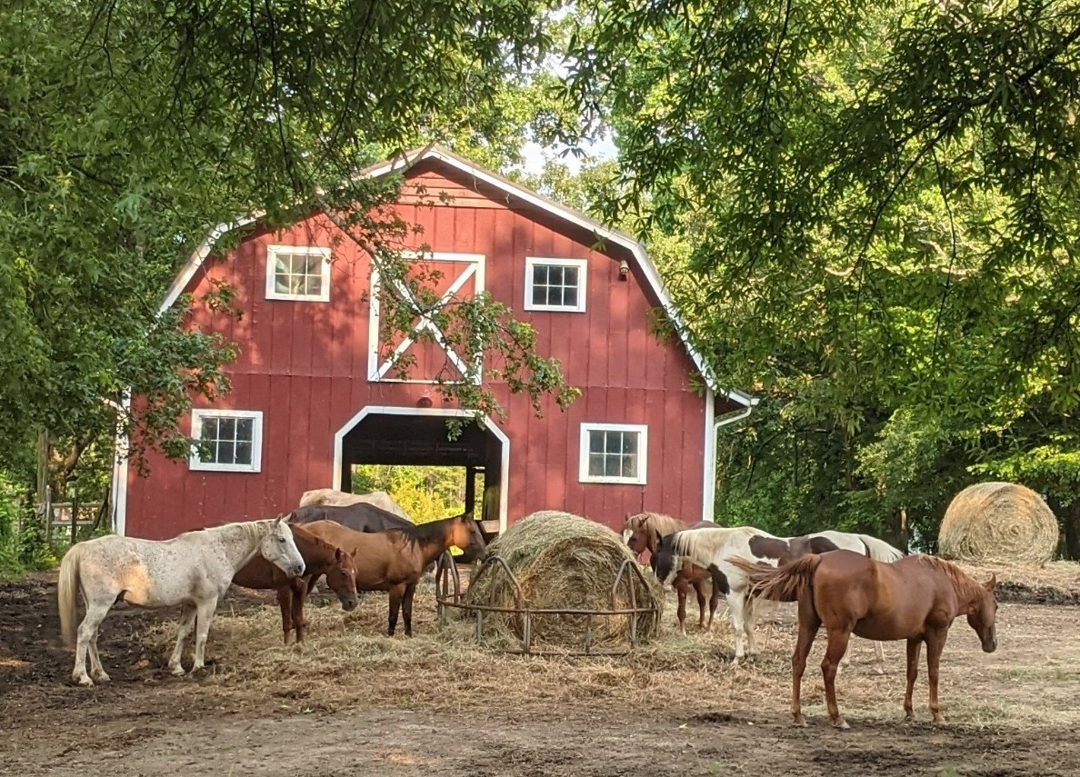

**Compassion Ranch**

**44 animals get second chances with food and shelter   
 and help inspire students to develop more**

**courage, patriotism, and compassion,**

**as well as plan and take more action on callings.**

**Model of Service**

1. **Compassionate care:** lifetime care of animals in sanctuary and support of other caregivers…
2. **Life Leadership:** Student development--Alabamacharacter traits *courage, patriotism, compassion…*
3. **Patriotism in Action:** riderless horse, *Veterans Day Started in Alabama* & *Pledge of Allegiance* Ed.
4. **Home of 2 military working equines from The Old Guard at Arlington National Cemetery**.
5. **People can enjoy and help horses** without need to purchase and board their own.
6. **Help solve root causes** of problem-causing behaviors of abandonment and abuse of animals.
7. **Public-private partnership:** 501 (c)(3) public programs provided at private land donated to use.

**Retired Military Working Equines from Arlington**

**Hank** helped lay to rest military heroes such as General Colin Powell as a caparisoned (riderless) horse at Arlington National Cemetery, led by cap walkers of The Old Guard. He retired after 10 years and was selected to retire with us.

the

**Hank the Tank** (Alabama nickname)served America’s oldest Veterans Day Parade (Birmingham since 1947) in 2023 as the first “riderless horse” from Arlington and he stood at the funeral of Col. Bob Barefield at the Alabama National Cemetery. In 2024, Hank was featured in the Birmingham Parade, this time with Sgt. Grant Hardy, squad leader for cap walkers in The Old Guard, the first time a cap walker and cap horse from Arlington National Cemetery walked together in this parade.

When not inspiring veterans and students, **Hank the Tank** lives in sanctuary in Central Alabama with **Lincoln** **and Wounded Warrior.** Lincoln also is a retired MWE (Military Working Equine) and Wounded is a former racehorse with permanent injury we adopted in honor of disabled Americans.

**Horses Rescued by Deputies**

after rescue from near death due to starvation they needed home with food and care

**<=Lancelot** weighed only 650 pounds the day of rescue. He has gained 300 pounds and healed from “rain rot.”

**Braveheart** => weighed only 550. He gained 200+ pounds. He had emotional and physical challenges for a year. Brave started fights with male horses three times, requiring vet care, post op, and extra care for weeks for one or more horses. Now, he enjoys pasture, shelter, and relaxing with his herd….

**20 Equines & Farm Animals Need Us**

*Abandonment or abuse is usually done by former students.  
Show your children and grandchildren what you value!*

*Visit, volunteer, donate, or advocate to help us care, teach, change.*

Animals & programs: [www.CompassionRanch.org](http://www.CompassionRanch.org)

Info, answers, opportunity: [Doc@CompassionRanch.org](mailto:Doc@CompassionRanch.org)

**Shetland Pony July**  **Donkeys Honk, Jill, June**rescued and surgery to help her walk. needed home after owners died.

**Meet Some of the Dogs & Cats + our Goat & Pig**

7 dogs and 17 cats enjoy the farmhouse, fenced yards, enclosed gardens, and barns

Charlie saved from euthanasia. Tabitha rescued from a pipe. Bendi needed home. Wilbur alive with friends.

**Triple D** was rescued from traffic on a county road after escaping from being tied to a tree with metal shock collar probes in his neck. His human tied him to a tree 24/7 instead of fix the fence. Now, “D” loves to run and play with his pack in their fenced yards, plus tell us when donated feeds and supplies arrive at the gate.

Rambo** had been tied to a tree for 3 days without food or water. A caller described distress howls he heard for days. We found Rambo 1,000 yards from his previous home in secluded woods.

*Do you agree we need more character traits education & development for students before they grow up & do this?*

After we rescued Rambo, he enjoyed fenced yard and home privileges to eat, sleep, and play for 1,000+ good days before he went to heaven—hugged as he went to sleep.

***We wish they could live with us forever though we remember them forever.***

Our callings include providing compassionate care giving animals a forever home with security, love, and purpose, plus handle their end-of-life experiences with love and dignity. A partner provides head stones for each animals buried in our cemeteries. Horses usually choose their place of final rest, and we remember them with photos and/or web pages.

We strive to teach and inspire students to treat animals with compassion so the next generation of adults will treat animals better—less likely to abandon, more likely to care and take action as responsible citizens.

*People tend to treat others similar to how they treat animals when no one is watching.*

**Compassion – Patriotism – Courage…aimed at Callings**

*At Compassion Ranch, we focus on improving lives of animals and people,   
laboring for and investing in food, care, shelter, safety, purpose, education, and positive experiences.*

Our first program: students from Camp Rockhurst learning of compassion and courage, animal care, and life leadership.

This student practiced facing fear and transformed from crying to more courageous.

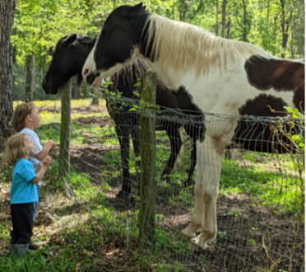

Kids and parents meet horses. Children learn & create memories.

**-----------------------------------------------------------------------------------------------------------------------------------------**

Compassion Ranch & Institute (formerly Life Leaders Institute) has **3 nonprofit programs**:

1. **Compassion Ranch:** Animal Care & Character Ed for *Compassion-Patriotism-Courage…*
2. **Life Leadership:** Personal Leadership, *Plan for School, College-Career-Calling & 7 Areas of Life*
3. **Patriotism in Action:** riderless horses, *America’s Veterans Day Started in Alabama education*…

Located in Central Alabama half-way between “horse country” of Kentucky and Florida.

Services and Support to the Animals provided by Friends of Compassion Ranch   
at Triple D Ranch & Farm led by Dr. David Dyson, trustee and volunteer ranch hand.

Explore possibilities: [Doc@CompassionRanch.org](mailto:Doc@CompassionRanch.org) or call David at (205)422-6484.

*We are full, feeding 44, though dream of more partners to add people, equipment, shelters, and land.*